23.Design DFA using simulator to accept the string the end with ab over set {a,b)

W= aaabab

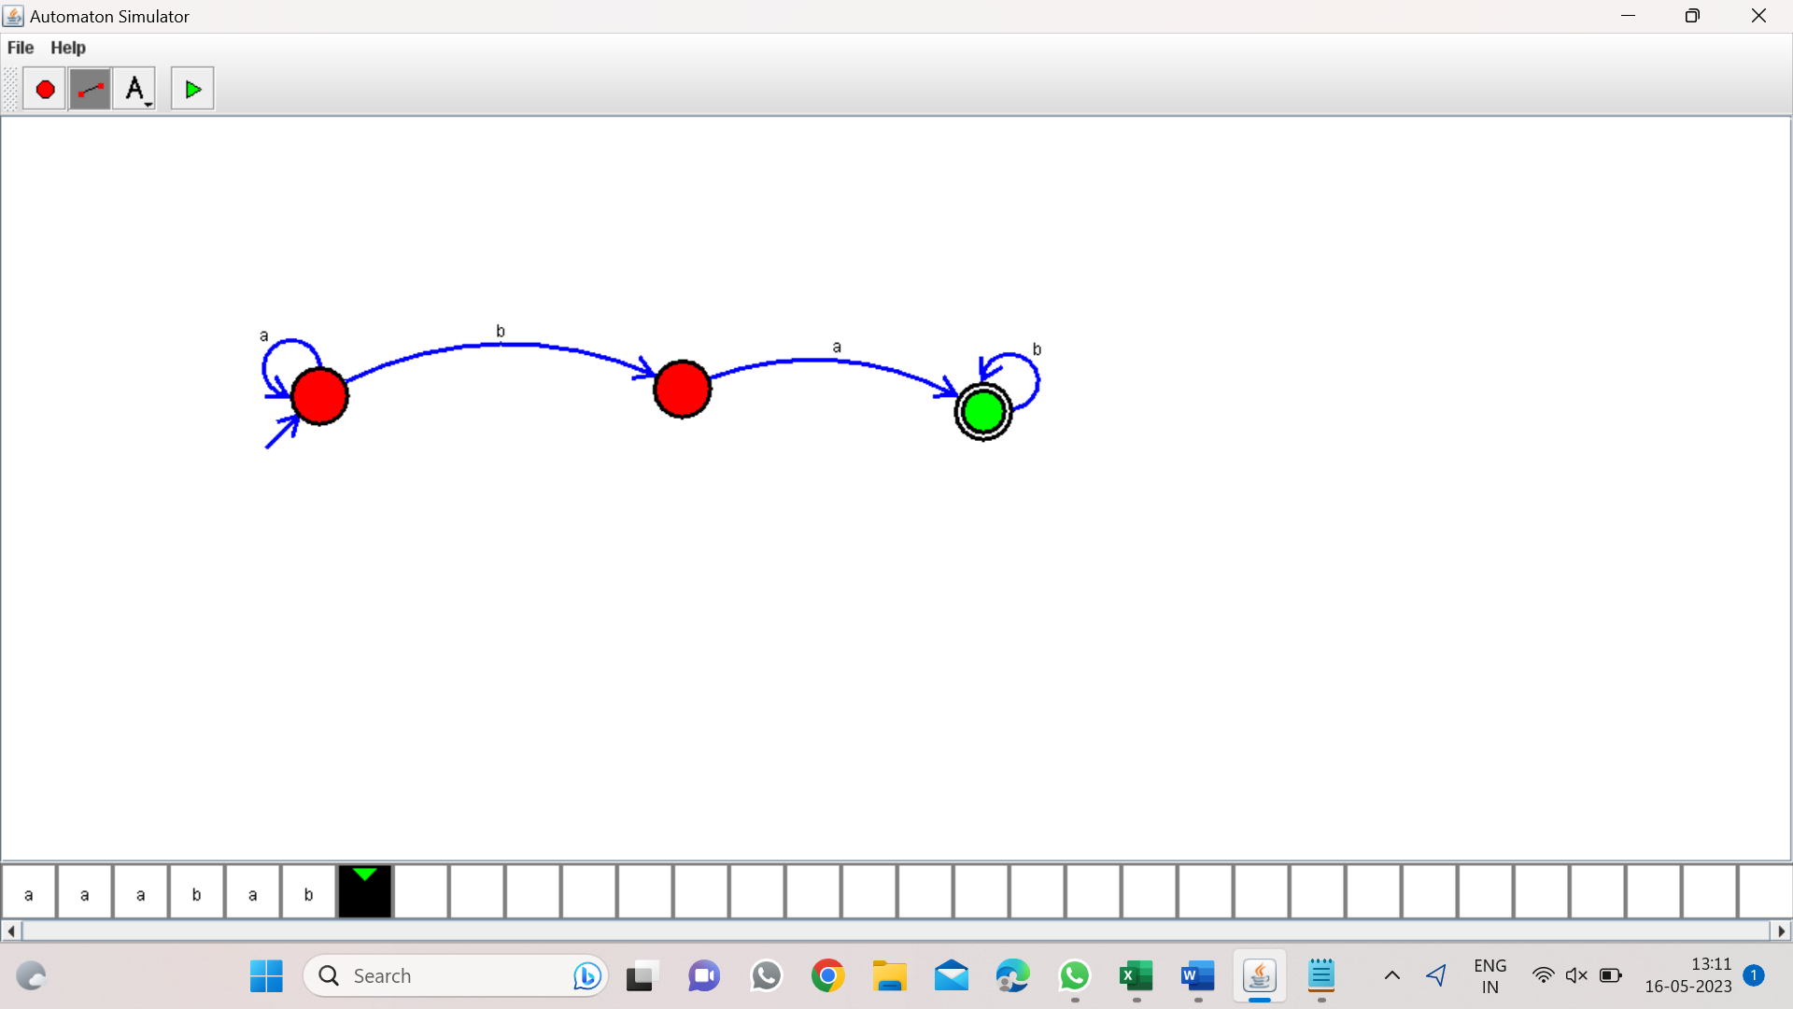

**Result**:- from the above DFA diagram valid the string aaabab